Linux Commands

Working with Directories

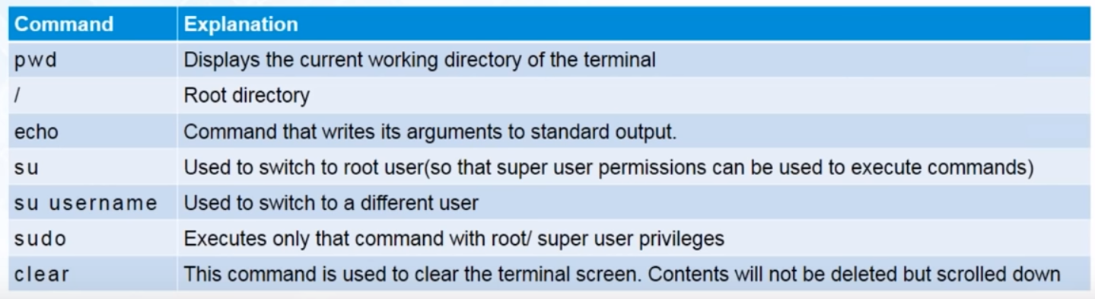

List Files

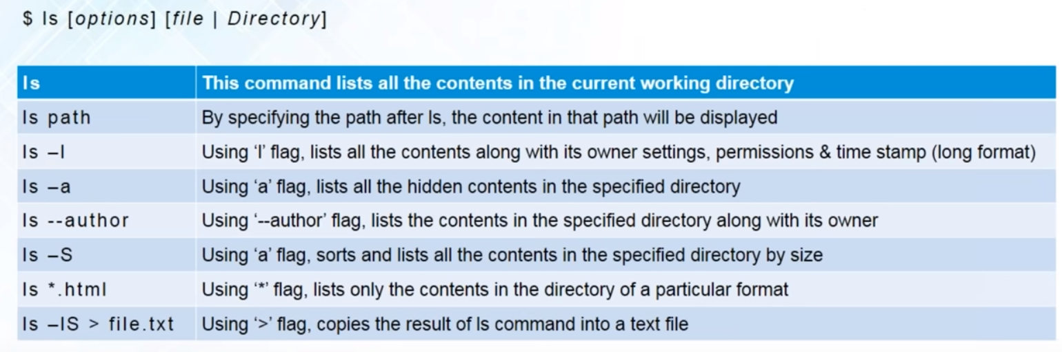

Change Directory

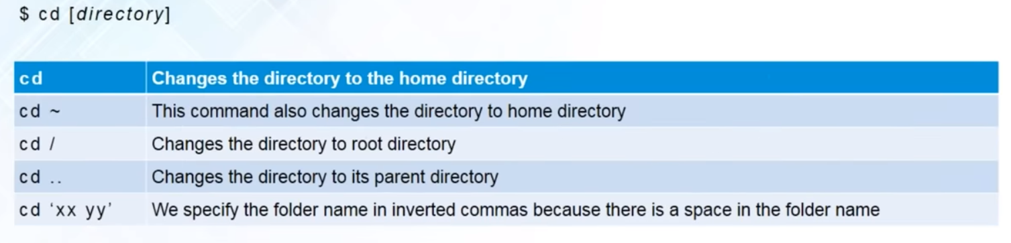

Cat

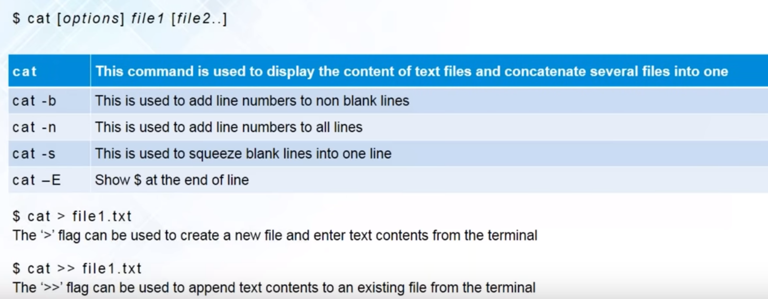

Copy

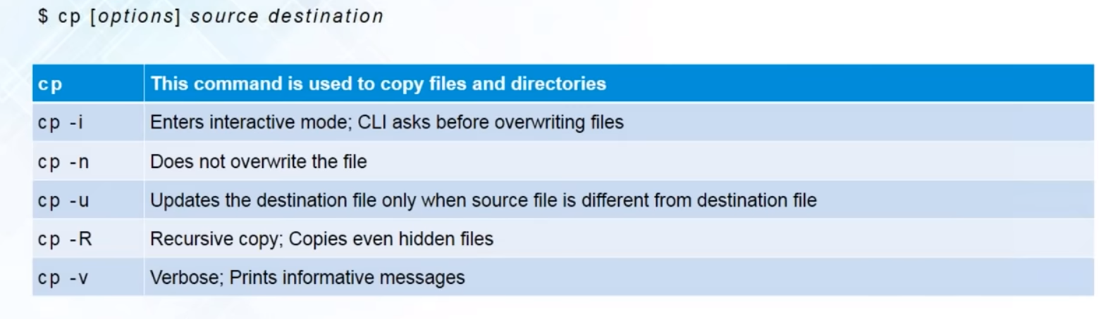

Move

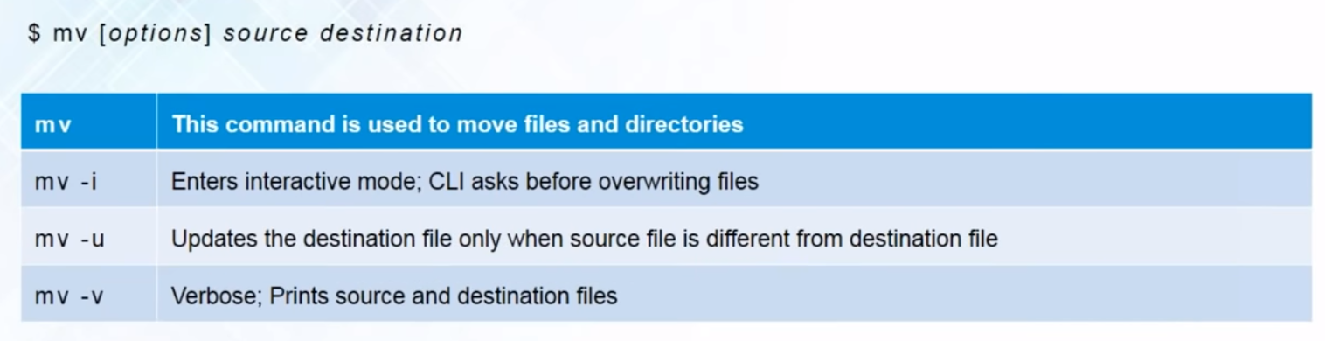

Create and Remove Directory

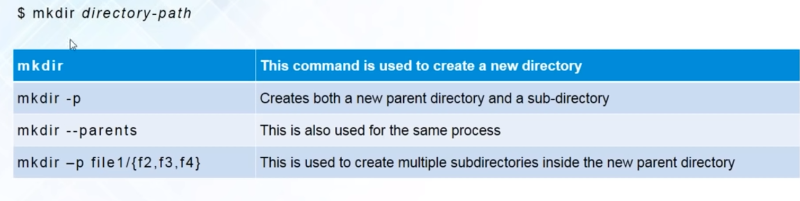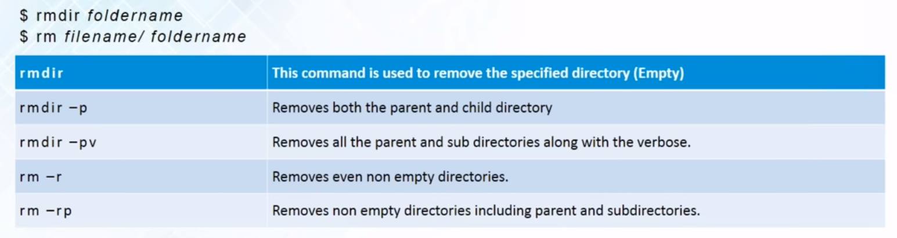



Working with User Permissions

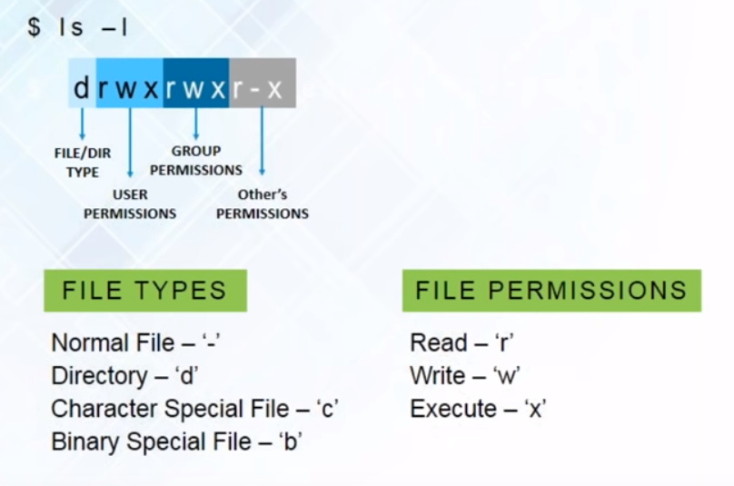

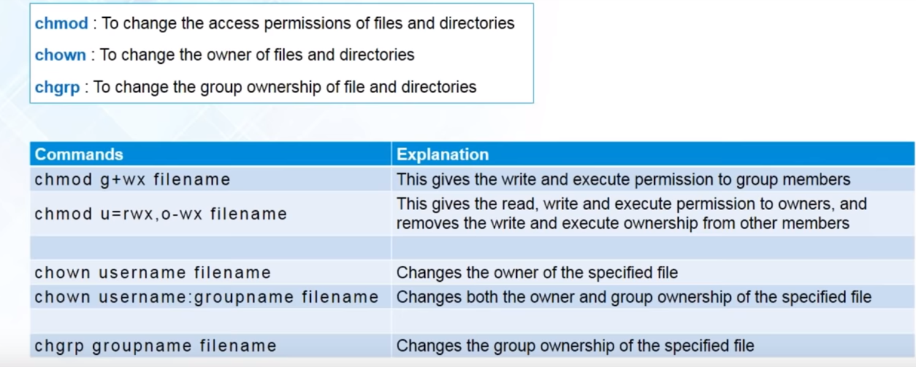

Working with Linux Repositories

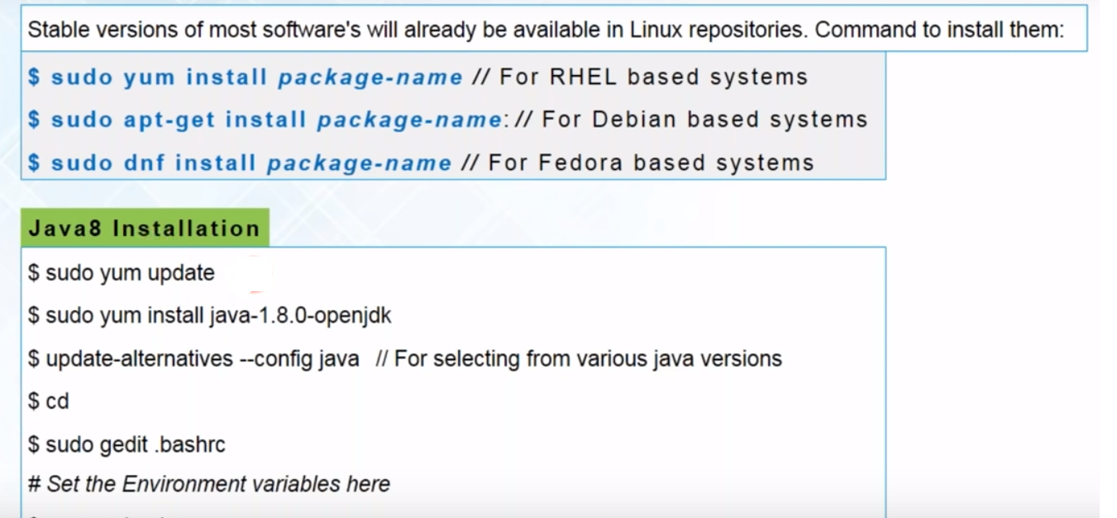

Working with tar files

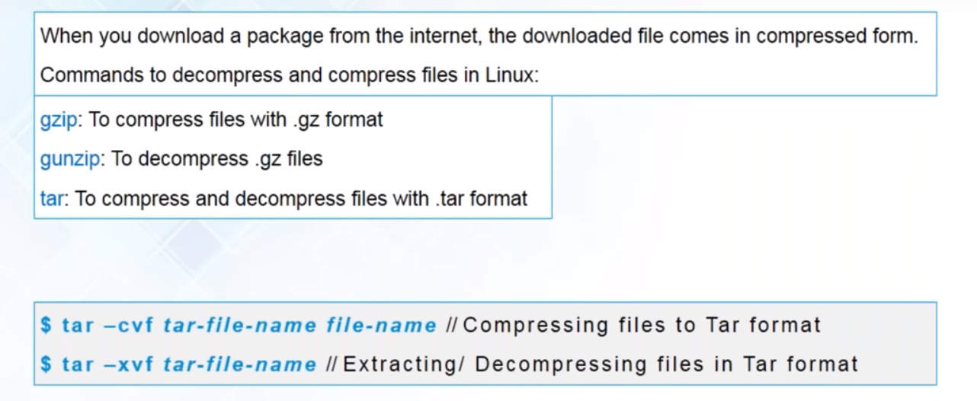

Environment Variables

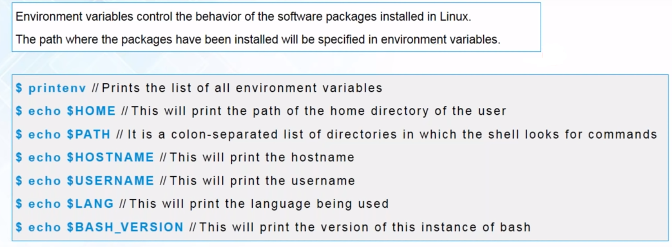

Creating Users

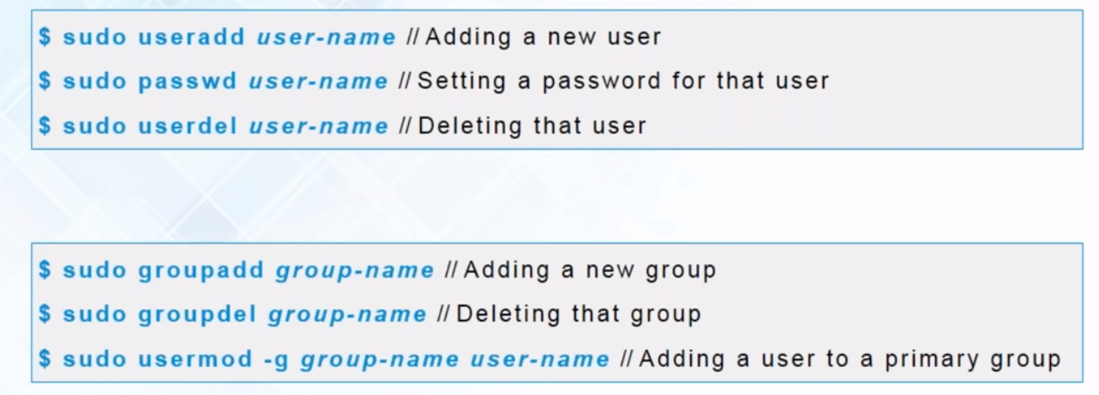

Editors

1. Vi Editor (Available by Default)

<https://www.guru99.com/the-vi-editor.html>

2. Nano Editor

sudo yum install nano - Redhat OS

sudo apt-get install nano – Ubuntu OS

<https://linuxize.com/post/how-to-use-nano-text-editor/>